**Handheld Function Generators**

<https://www.alibaba.com/product-detail/VICTOR-270S-Handheld-Oscilloscope-And-Multimeter_1600607609559.html?spm=a2700.galleryofferlist.normal_offer.d_image.154e78cfw1asCL>

**Price:** >=1 piece US$179.00

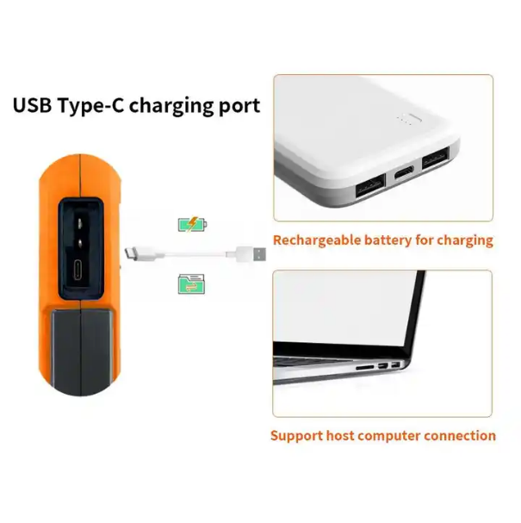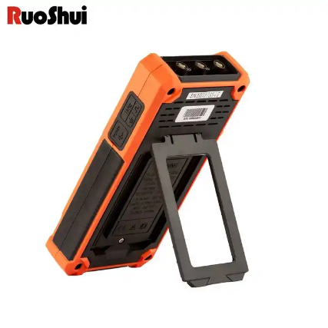

**Product Name:** GAOTek Handheld Oscilloscope And Multimeter

**Product ID:** GAOTek-HFG-201

**Overview:** GAOTek Handheld Oscilloscope And Multimeter is a new oscilloscope, it is recommended that you should make a check on the instrument according to the following. steps. Check whether there is any damage caused by transportation. If it is found that the packaging carton or the foamed plastic protection cushion has suffered serious damage, do not throw it away first till the complete device and its accessories succeed in the electrical and mechanical property tests. Check the Accessories  
The supplied accessories have been already described in the "Appendix A: List of Accessories" of this Manual. You can check whether there is any loss of accessories with reference to this description. If it is found that there is any accessory lost or damaged, please get in touch with our distributor responsible for this service or our local offices. Check the Complete Instrument  
If it is found that there is damage to the appearance of the instrument, or the instrument can not work normally, or fails in the performance test, please get in touch with our distributor responsible for this business or our local offices. If there is damage to the instrument caused by the transportation, please keep the package. With the transportation department or our distributor responsible for this business informed about it, a repairing or replacement of the instrument will be arranged by us.

**Technical Specifications:**

|  |  |
| --- | --- |
| **Display type** | 3.5 inch color LCD display |
| **Display resolution** | 320 pixels × 240 pixels |
| **Display color** | 65536 colors |
| **Display Contrast** | Adjustable |
| **Power supply** | 100 240 VACRMS, 50/60 Hz, CAT Ⅱ DC INPUT: 5VDC, 2A |
| **Battery** | 2200 mAh x 2(3.7 V,18650) |
| **Relative humidity** | ≤90% |
| **Height** | Operating 3,000 meters  Nonoperating: 15,000 meters |
| **Cooling method** | Natural cooling |
| **Storage temperature** | 68 °F to 104 °F (20 ℃ to +60 ℃) |
| **Temperature** | 32 °F to 104 °F (0 ℃ to 40 ℃) |
| **Dimensions** | 7.79 in x 3.78 in x 1.48 in (198 mm × 96 mm × 38 mm ) |
| **Weight** | 1.322 lb (0.6 kg) (main unit, without battery) |

<https://www.alibaba.com/product-detail/DECCA-24-Handheld-Multifunction-Process-Calibrator_1601008206894.html?spm=a2700.galleryofferlist.normal_offer.d_image.453378cfQOh>

**Price:** >=5 to 49 pieces US$1,000.00

>= 50 to 99 pieces US$780.00

>= 100 pieces US$680.00

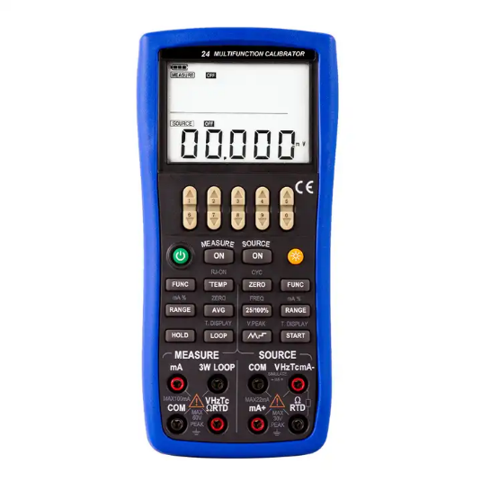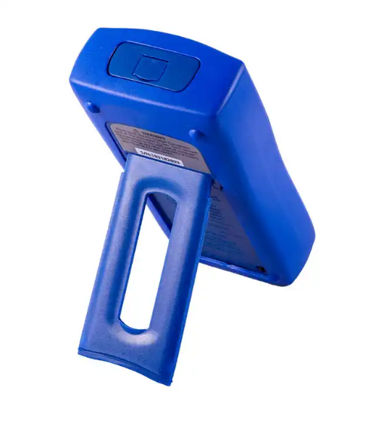

**Product Name:** GAOTek temperature monitoring function calibrator

**Product ID:** GAOTek-HFG-202

**Overview:** GAOTek temperature monitoring function calibratorhas 0.02% Accuracy Two Independent Channels For Input And Output 5 Digits Display. You can operate the measurement and source function simultaneously. The LCD screen is divided into two separate districts, whose upper part displays measurement information and lower part displays source information.TC measurement/source terminals and built-in lead connector of same temperature (RJ compensation with auto-reference joint point).Manual step source and auto -step and sweeping –step source. Room temperature monitoring under any operation. Measurement/source temperature monitoring function. Measurement/source mA% display. Measurement wave-filter function. Measurement manual-holding function. Pressure source auto-holding function. Standard Accessories Make sure that the package contains all the accessories listed below. And if you find they are damaged or any of them is missing, please contact the vendor from which you purchased the product as soon as possible. Refer to the replaceable optional accessories list in 15.3 in the Manual if you want to replace the parts or optional accessories. Two set of Industrial testing Lead (CL727220).A set of Testing Lead (Tp727110).A set of Alligator clip (CC807130).A Thermocouple Convertor (TTK07210). A quick reference guide. A User's Manual. One Fuse 50mA/250V.One Fuse 63mA/250V

**Technical Specifications:**

|  |  |  |
| --- | --- | --- |
| **Range** | -10 mV to 110 mV | |
| **Accuracy= ±(% of the set value+% of range)** | 0.02% +0.01% | |
| **Resolution** | 1 uV | |
| **DC voltage Range** | -0.1 V to 11 V | |
| **Accuracy= ±(% of the set value+% of range)** | 0.02% +0.01% | |
| **Resolution** | 10 uV or 0.1mV | |
| **DC current Range** | 0 mA to 22 mA | |
| **DC current Accuracy= ±(% of the set value+% of range)** | 0.02%+0.02% | |
| **Resolution** | 1 uA | |
| **Resistance Range** | 0 KΩ to 40 KΩ | |
| **Resistance Accuracy= ±(% of the set value+% of range)** | 0.02%+0.02% | |
| **Resistance Resolution** | 0.01 Ω/0.1 Ω/1 Ω | |
| **RTD Range** | Pt100/Pt200/Pt500/ Pt1000/Cu10/Cu50 | |
| **RTD Accuracy** | 32.36 °F (0.2℃) | |
| **RTD Resolution** | 32.18 °F (0.1℃) | |
| **Frequency Range** | 1 Hz to 110 KHz | |
| **Frequency Accuracy** | ±2words | |
| **Frequency Resolution** | 0.01 Hz/1 Hz/0.1 KHz/2 KHz | |
| **Withstand voltage** | | The input and output AC350V/1 minutes |
| **Insulation** | | The input and output DC500 V /50 MΩ. |
| **EMC** | | EN61326-1：2006 |
| **Authentication** | | CE |
| **Display** | | Double display on the LCD screen |
| **Power supply** | | 4×1.5 V AAA Alkaline battery |
| **Size** | | 8.07 in x 3.74 in x 1.64 in (205 mm × 95 mm × 42 mm) |
| **Weight** | | 1.10 lb (0.500 kg) |

<https://www.alibaba.com/product-detail/Taidacent-Handheld-0-10V-4-20mA_1600655840944.html?spm=a2700.galleryofferlist.normal_offer.d_image.657c78cfQTgtHc>

**Price :** >= 5 to 24 pieces US$20.18

>= 25 to 99 pieces US$19.68

>= 100 to 499 pieces US$19.18

>= 500 pieces US$18.18

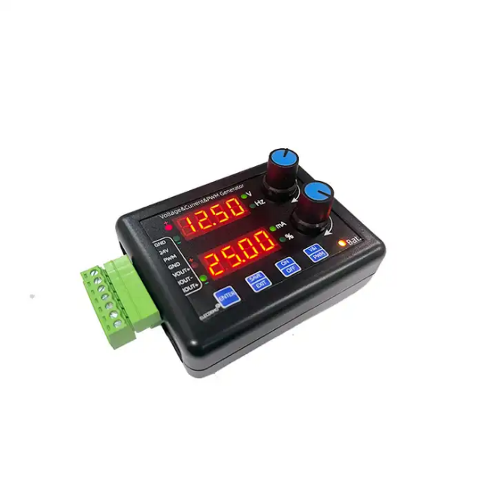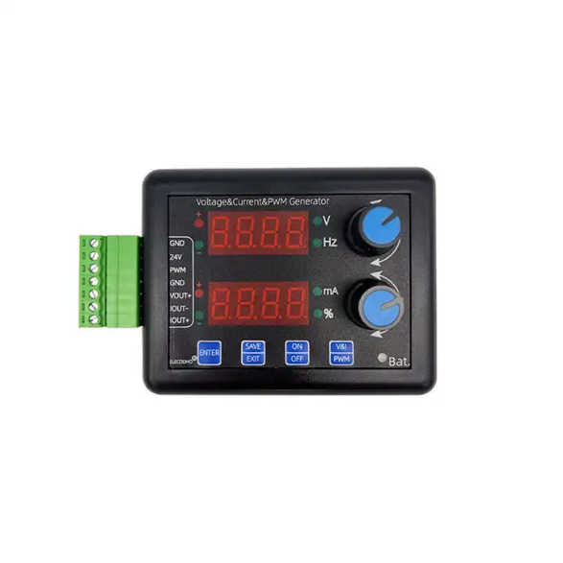

**Product Name:** GAOTek Analog Function Generator with Display

**Product ID:** GAOTek-HFG-203

**Overview:** GAOTek Analog Function Generator with Display voltage and current square wave independent adjustment, independent display, independent generation, voltage source + current source + square wave (PWM) source, three sources Adjustment method description: voltage current/square wave frequency duty, there is an independent adjustment knob, turn clockwise to add a step output, counterclockwise to decrease a step output, press the knob, the adjustment position scrolls forward one position (the adjustment position will flashing).

**Technical Specifications:**

|  |  |
| --- | --- |
| **Power supply** | DC12 V to 30 V/ Micro USB 5 V |
| **Short output** | Yes |
| **Power supply protection** | Yes |
| **Voltage range** | -12.5 V to 12.5 V |
| **Voltage accurate** | 0.01 V |
| **Voltage step** | 0.01 V |
| **Current range** | -25 mA to 25 mA |
| **Current accurate** | 0.01 mA |
| **Current step** | 0.01 mA |
| **Square wave frequency** | 1 Hz to 5 Khz |
| **Frequency step** | 1 Hz |
| **Frequency accurate** | 0.2 Hz |
| **Square frequency duty step** | 0.1% |
| **Size** | 4.21 in x 2.56 in x 1.69 in (107 mm x 70 mm x 43mm) |